Part 3
Creating a Language-rich
Environment for Nurturing Positive
Values and Attitudes

3.1 Tree of Hope
Mount a “Tree of Hope” in the school playground or on the class noticeboard for teachers and students to share their thoughts and reflections on “hope”.

Some ideas for creating a “Tree of Hope”
Write words of encouragement on leaf cutouts.
Create a collage of photographs which captures special moments of hope.
Fold paper birds in origami style to add to the tree and write messages of hope on their wings.
Make art and write personal goals on it. Stick them on the tree.

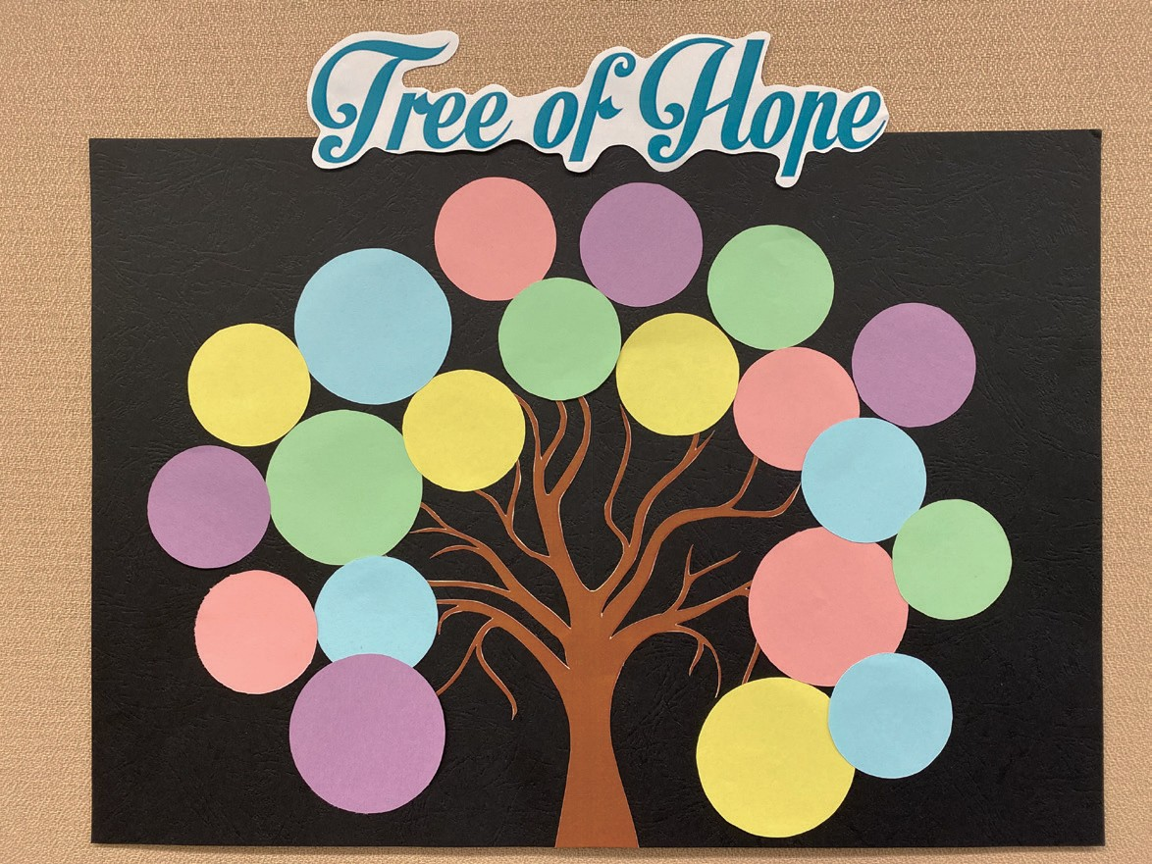

  - “What Brings You Hope?” Wall
Invite students to write their thoughts on what brings them “Hope”.
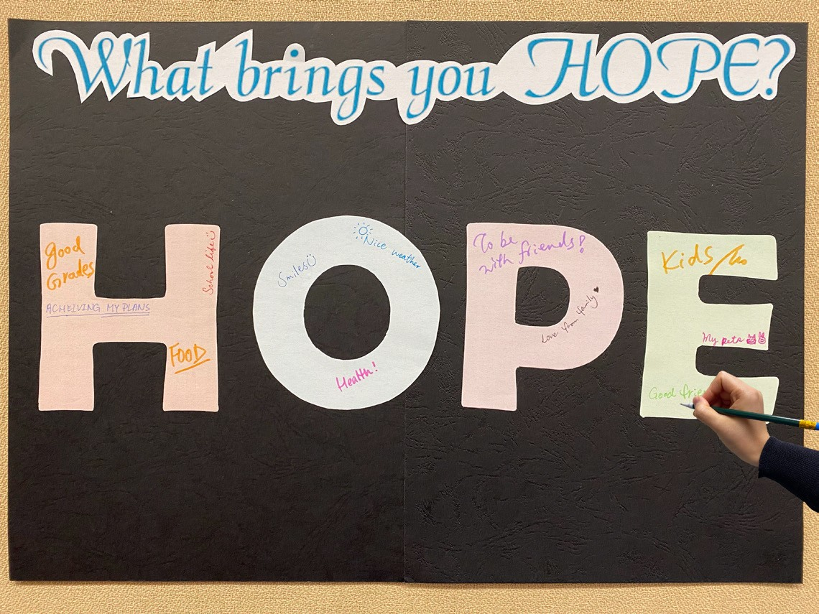

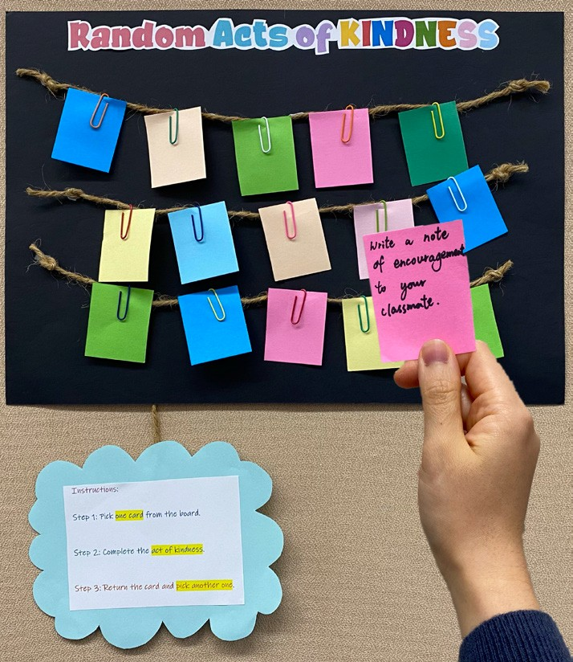
A Display Board on “Random Acts of _____” (e.g. Kindness, Love)
Design a display board on “Random acts of
” (e.g. kindness, love, courage) in the school playground or on the class noticeboard. Each card describes an action for students to complete (e.g. recommend a book about kindness to your friend, share an inspirational quote about hope to three classmates, write words of encouragement on a card and place it on your classmate’s desk). Post the following instructions on the board:

Step 1: Pick a card.
Step 2: Complete the act of kindness/love/courage.
Step 3: Pass your card to a friend to pay it forward.

Quote/Picture of the Day
Instruct students to take turns to stick an inspirational quote/picture of the day on the class bulletin board. Get them to do a mini-sharing on the quotes/pictures before the lessons.
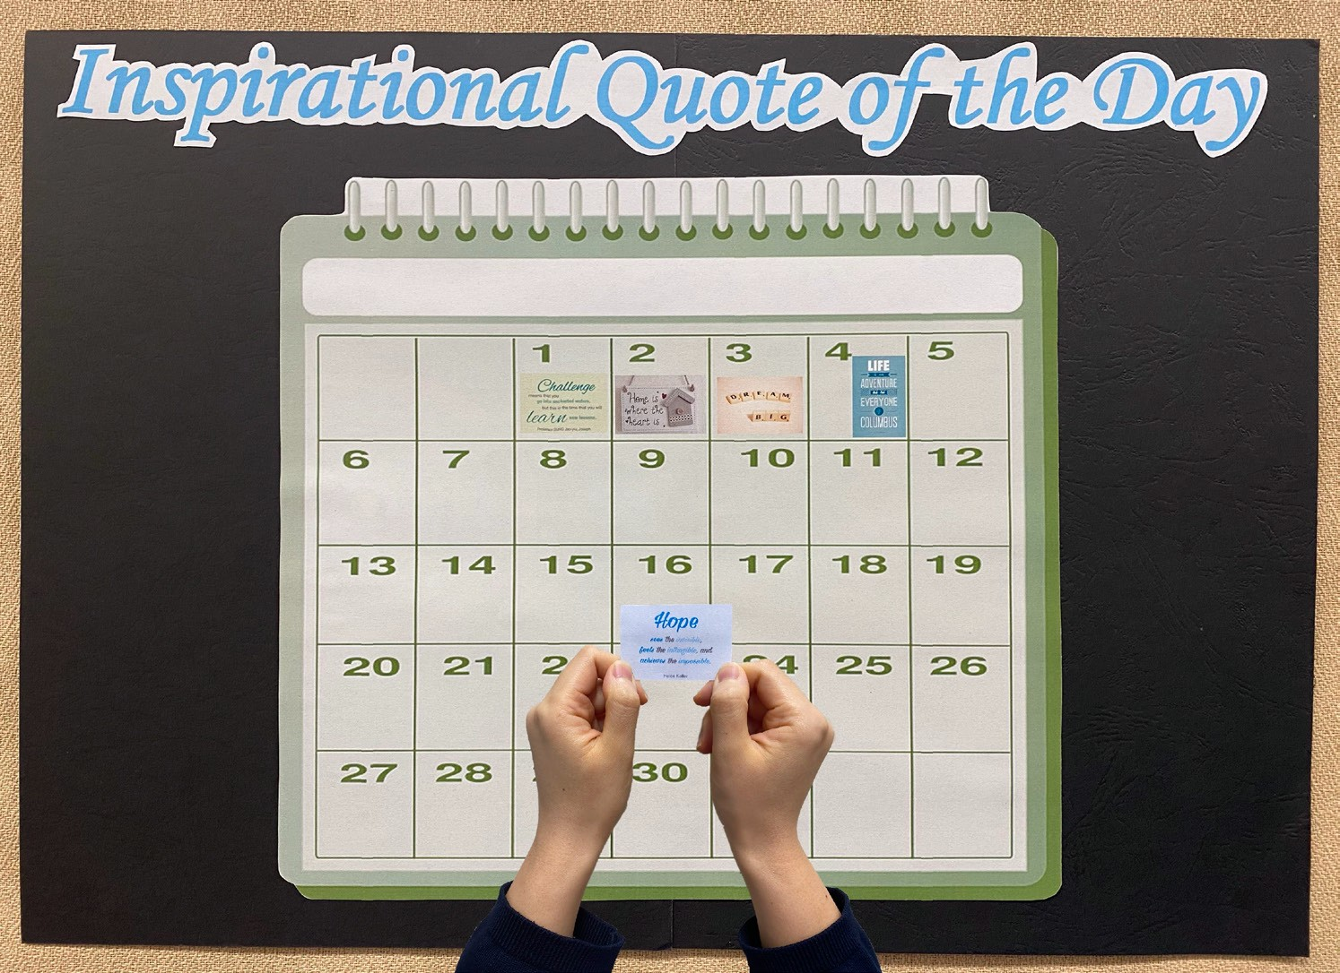

Interactive Board Display on Thematic Book Recommendation
Select a theme (e.g. hope, perseverance, overcoming challenges) and have an interactive book recommendation board display in the school playground or on the class noticeboard. Below are a few suggestions on what to put on the cover and the inner page to elicit students’ interest:

Title of the Board | Cover Page | Inner Page
Which book says this? | Select a quote from the book | Introduction of the book
Come take a look at your teacher’s favourite book on  (theme)! | Name of teacher | Introduction of the book by the teacher and the reason for choosing the book
What’s the name of the book? | Picture of the book cover (without the book title) | Book title and introduction of the book
Stories on (theme) from around the world | Flag/name of the country | Introduction of the book
Books from inspiring people | Picture of the book cover | Introduction of the book
Fascinated by the first line? Grab the book in the school library. | First line of the book | Picture of the book cover
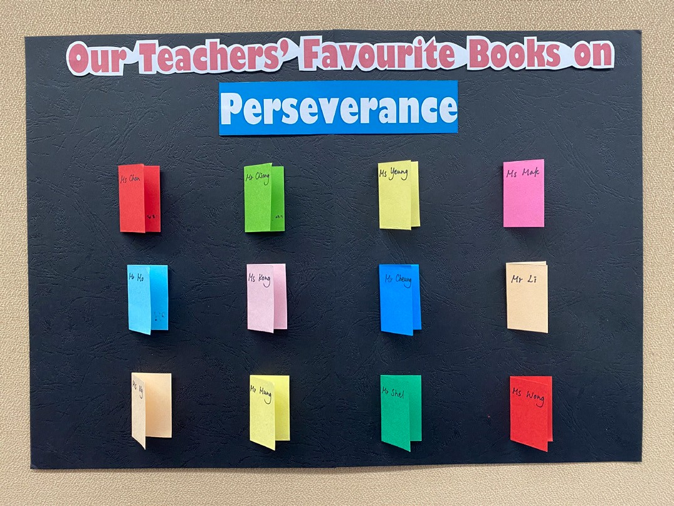

Word Search Wall
Design word search games on different positive values and attitudes using online tools. Place them on different walls/display boards in the school premises. Prepare reusable frames for students to stick on the wall when they find the word. Place a printed/digital dictionary (e.g. installed on a tablet computer) to encourage students to search for the new words learnt (see a sample word search puzzle on hope on p.55).
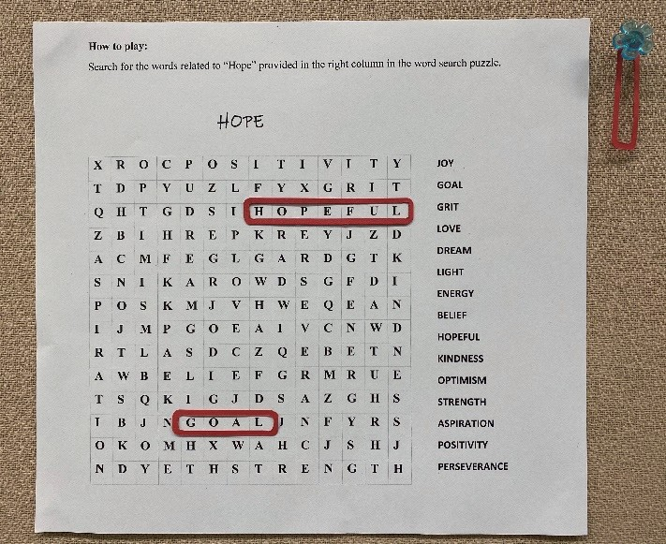

A Cootie Catcher on Hope
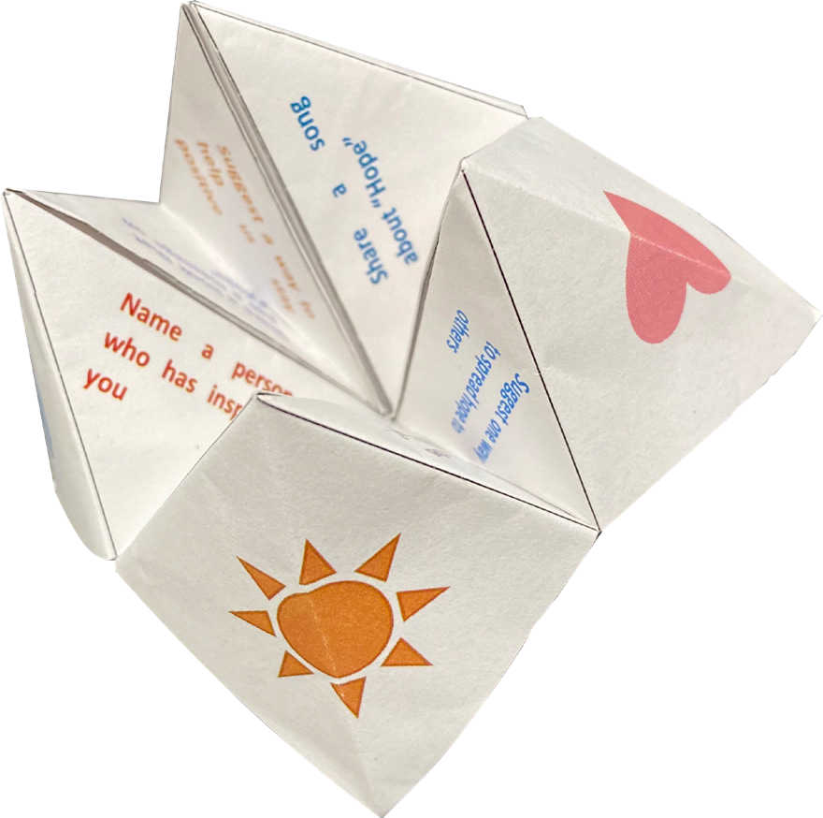
Provide a template of a cootie catcher for students. Invite them to write “Hope Challenges” under the flaps of the cootie catcher (see a sample and the steps for making a cootie catcher on pp.57 and 58).

A Book Hunt Competition
Select a positive value (e.g. hope, integrity, resilience) to be the monthly theme. Have students search for a book in the school library that matches the monthly theme. The book can be of any genres, for instance, a biography, a story or a self-help book. Invite students to conduct a one-minute sharing about the book they have selected with three people (e.g. the principal, teachers, parents, siblings, classmates) and record the sharing in a logbook.

Hope Clouds
Design a cloud template (e.g. a speech bubble, a thought bubble, a star). Ask students to write about their dreams as well as people and things that bring them hope. Post the “Hope Clouds” in the school premises. Get students to walk around to find their favourite “Hope Cloud”.
I stay hopeful by appreciating the people and things around me.

My dream is to be a vet. I want to take care of animals that are sick.

My life motto
Fall down seven times, stand up eight.

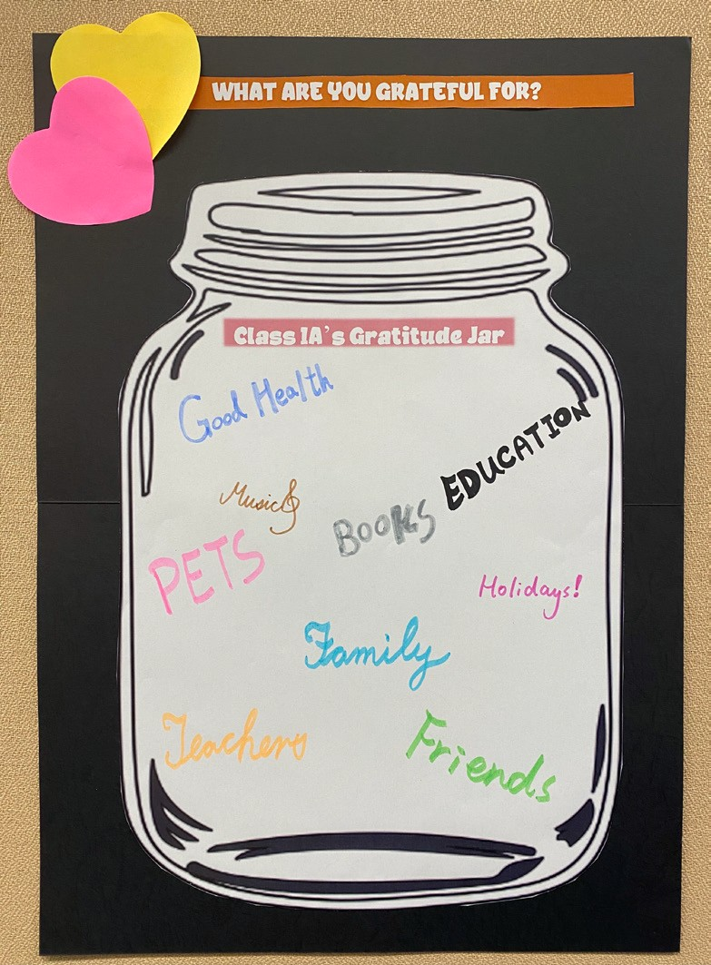
Gratitude Jar
Invite students to decorate a gratitude jar to be put up on the class noticeboard. Assign different themes for the task (e.g. what you are grateful for, a line to someone who you are thankful to, things to do to express gratitude to others) and ask students to write their thoughts to put in the jar.

Creative Book Display in the School Library
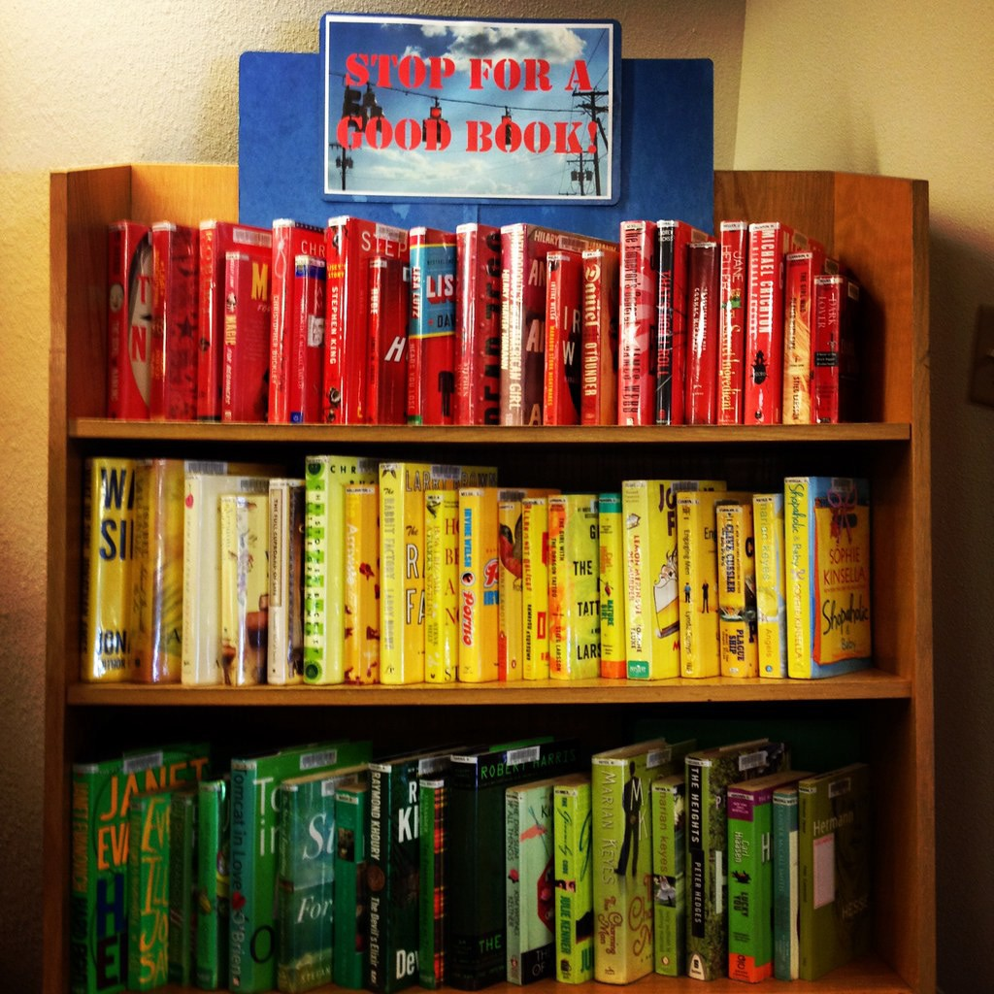
Display books in the school library/class library/reading corners on school campus to introduce books related to the monthly theme. Invite teachers/students/parents to promote the books through different channels (e.g. a poster, a speech in the morning assembly, a note on the school intranet).

Suggested themes:
Failure is the stepping stone to success. Stay hopeful.
Have faith in yourself.
Be perseverant.

Gratitude Calendar
Design a class gratitude calendar and mount it on the class noticeboard. Ask students to write down what they are thankful for on a piece of colourful paper. Stick the paper on the calendar and invite students to explain what they have written. Or design a calendar on other positive values and attitudes to cover a different theme each month.

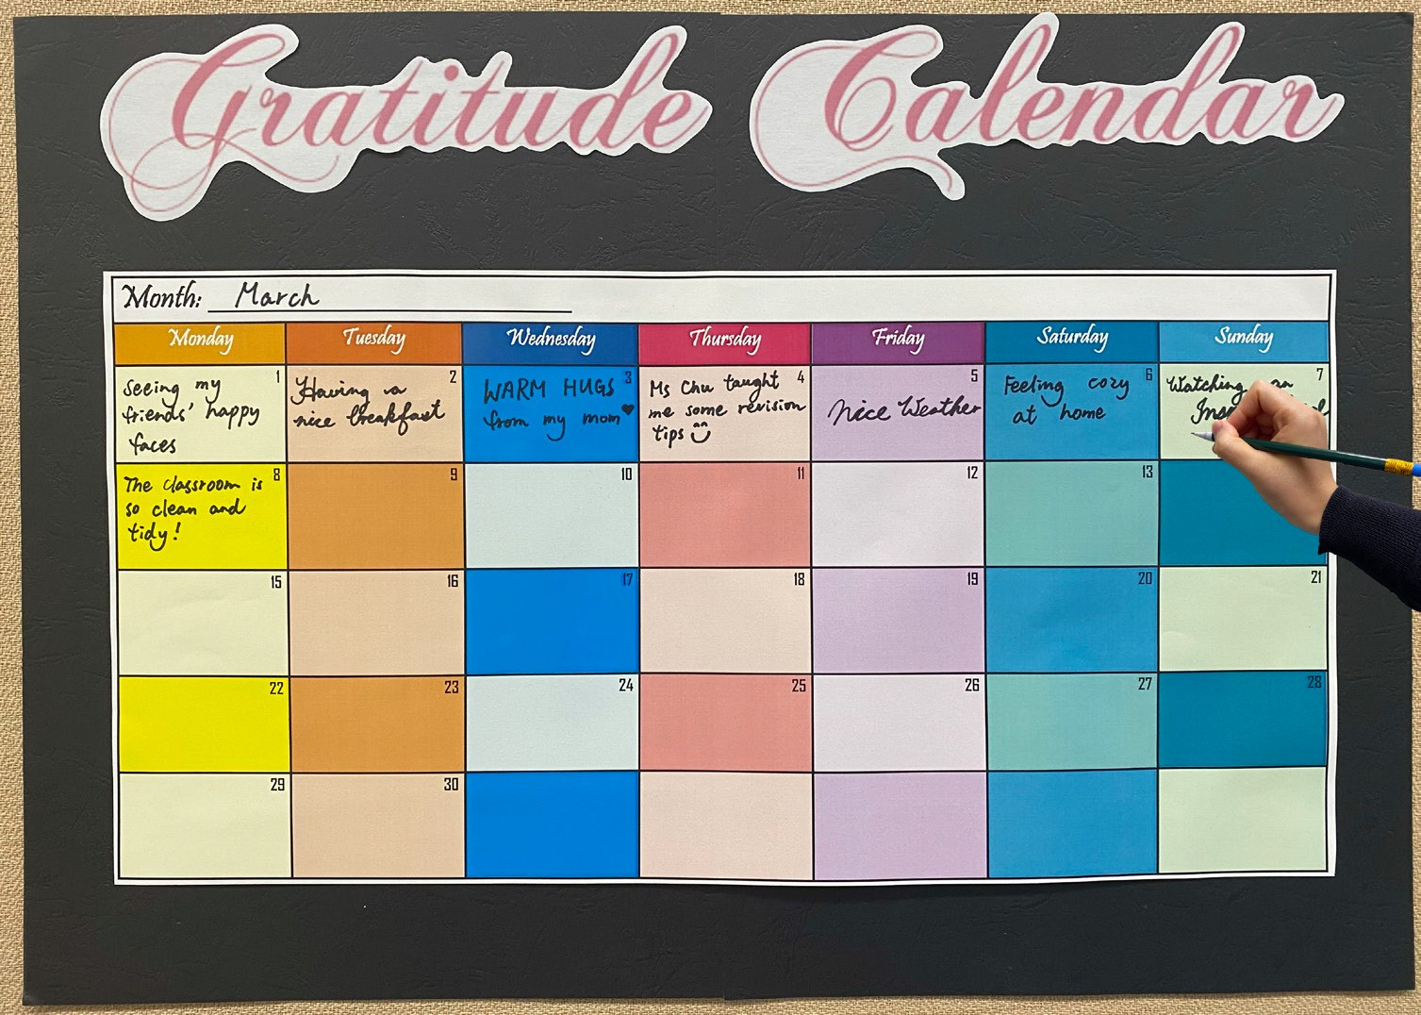

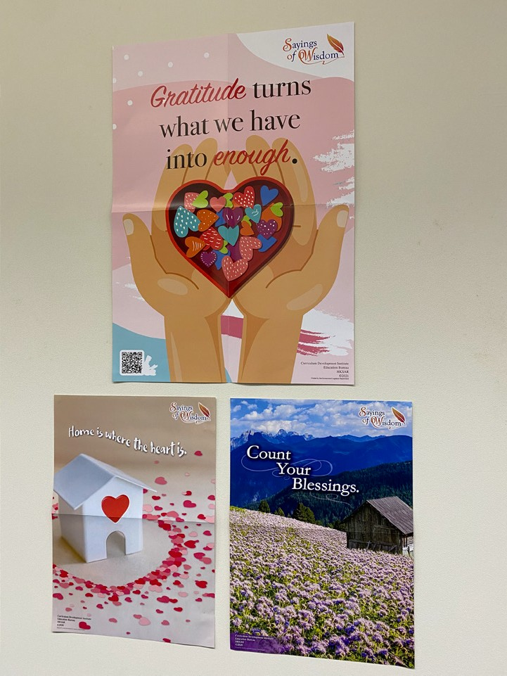
Poster Display
Decorate the classrooms/school campus with posters which spread positive values and attitudes to create an engaging learning environment using different series of posters (e.g. inspirational quotes by successful people, proverbs from around the world, mottos of famous athletes).

